A FUTURE FOR FISHERIES?
Towards effective strategies for sustainability
Leuven, 5 February 2008
Auditorium Zeger Van Hee, College De Valk
Tiensestraat 41
Leuven, Belgium
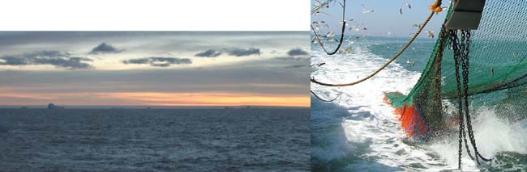
You are kindly invited to this symposium on the occasion of the honorary doctorate
awarded to
Daniel Pauly
by the Katholieke Universiteit Leuven
The ocean and coastal seas have always been a wealthy source of fish, shellfish and crustaceans. But the increasing efficiency of fishing techniques and the ever increasing scale of the fishing sector outgrew the sustainability of the system. As a result, today’s waters are empty compared to the oceans of the past…
The fisheries biologist Daniel Pauly was one of the first to confront us with the reality of the world-wide overfishing problems. In the course of his scientific career, he developed models and instruments to quantify the far-reaching effects of the fishing industry on the fish stocks and the marine and freshwater ecosystems. It was Pauly who developed the concept of ‘fishing down the foodweb’ describing the phenomenon of the over-exploitation of long-lived predatory fish, like tuna and cod, finally leading to a shift in fishing the smaller pelagic species and invertebrates at lower trophic levels. He is co- founder of the world’s largest online fish encyclopedia ‘FishBase’ and is now leading ‘The Sea Around Us’ project that collects and redistributes world-wide data on marine ecosystems. During his career he published several books and more than 500 scientific papers, of which many in high standing journals like Science and Nature.
On the occasion of the doctorate honoris causa awarded by the KULeuven to Daniel Pauly, a group of outstanding ecosystem management and fisheries scientists are gathered for the Symposium ‘A future for fisheries? Towards effective strategies for sustainability’. The symposium takes place on Tuesday 5 February 2008 (10:00–18:00) at the downtown campus of the Katholieke Universiteit Leuven, Belgium under the patronage of its rector. The aim is to present a state-of-the-art on the dire position of global fisheries resources and discuss the strategies for sustainable development. The issue is approached from different angles: archaeology, econo-ecology, systems biology, fish and fisheries sciences, marine ecosystem biology, and marine law. The presentations (in English) are followed by a discussion on a vision of the future, that will be moderated by the environmental editor Charles Clover (The Telegraph, UK). The conference welcomes academics, science policy makers, professionals, students, journalists and other stakeholders. Attendance is free but registration is compulsory.
PROGRAMME
09:30 – 10 :00
Registration
10:00 – 10:20
Introduction
Dr Marc Vervenne
Rector of the Katholieke Universiteit Leuven (Belgium)
10:20 – 11:00
The Prehistory of Intensive Sea Fishing
Dr James Barrett
University of Cambridge – Department of Archeology (UK)
11:00 – 11:40
Modelling and Measuring the Process of Watershed Change, and Implications for Fisheries
Dr Karen Limburg
State University of New York – College of Environmental Science and Forestry (USA)
11:40 – 12:20
The Overlooked Evolutionary Dimension of Modern Fisheries
Dr Ulf Dieckmann
International Institute for Applied Systems Analysis – Evolution and Ecology Program
(Austria)
12:30 – 13:30
Lunch
13:30 – 14:10
Integrated Management of Marine Ecosystems and the Role of Marine Protected Areas
Dr Han Lindeboom
Wageningen IMARES (The Netherlands)
14:10 – 14:50
Legal Perspectives in Coastal Zone Management
Dr Frank Maes
Ghent University – Maritime Institute (Belgium)
14:50 – 15:30
Impact of Fisheries and Global Warming on Marine Ecosystems and Food Security
Dr Daniel Pauly
University of British Columbia – Fisheries Centre (Canada)
15:30 – 16:00
Coffee-break
16.00 – 17.00
Is there a future for fisheries?
Panel discussion moderated by Charles Clover
Environmental editor (The Telegraph, UK)
17:00 – 18:30
Reception
Registration is free, but compulsory before 25 January 2007 at info@vliz.be
REGISTRATION DETAILS
Name:
Organization/affiliation:
Address:
Tel.: Fax.: E-mail:

Special dietary needs: □ vegetarian
□ I will attend the reception
Fax or e-mail before 25 January 2008 to:
Flanders Marine Institute
InnovOcean site – VLIZ
Fax +32-(0)59-34 21 31
E-mail: info@vliz.be
Organizers:
Katholieke Universiteit Leuven,
Royal Museum for Central Africa Tervuren,
Royal Belgian Institute of Natural Sciences,
Institute for Agricultural & Fisheries Research,
Flanders Marine Institute
 |  | 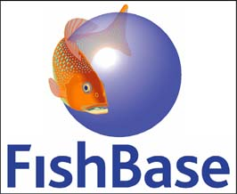 | 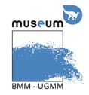 |  | 
Click here for a situation map and click here for a detailed route description.

